 France HABE Prize 2026

INTRODUCTION

The France Habe Prize is awarded by the Karst and Cave Protection Commission of the International Union of Speleology (UIS).

Its purpose is to promote the protection of karst and caves for future generations. Their natural heritage is an increasingly rich source of proven information about the history of our planet and humanity, enabling us to act more thoughtfully, effectively, and sustainably for the future of our environment.

At the suggestion of his successor, the prize is named in memory and honor of Dr. France Habe († December 10, 1999) of Slovenia (Yugoslavia), who, among her many occupations and achievements, notably served as Chair of the UIS Protection Department from 1973 to 1997.
The Prize will be proposed annually. It will be awarded if a worthy candidate is nominated and accepted. The awards for the four-year period will be officially announced at the International Speleological Congresses (CIS) during the second UIS General Assembly. A description of the individual or organization receiving the award and the reasons for it will be published on the UIS website and in the UIS Bulletin. The jury will consist of at least three members.
Nominations must be submitted to the award secretariat no later than May 20 of the current year. The jury will review the nominations and send its decision to the UIS Bureau. The jury is not obligated to award the prize each year if the candidates are not deemed worthy.

REGULATIONS OF THE FRANCE HABE PRIZE AWARDED BY THE KARST AND CAVE PROTECTION COMMISSION OF THE INTERNATIONAL UNION OF SPELEOLOGY
1. HISTORY
On September 30, 2012, the UIS Bureau allocated a budget of €250 to create a prize to be awarded every four years at the CIS during the second UIS General Assembly. It was first awarded in 2013.
At its meeting in July 2013, the UIS Bureau decided to award this prize annually thereafter.

2. Subject
The France HABE Prize, awarded by the UIS Karst and Cave Protection Commission, aims to promote the protection of karst and caves. It recognizes the best or most significant action, concrete idea, or publication for the protection of a cave, a karst area, or the underground environment in general.

3. Award
The France HABE Prize has been awarded annually since 2013.
The prize amount is currently €300. The UIS Bureau will set the prize amount for subsequent years. The France HABE Prize is open to any individual, club, local federation, commission, or national federation, with preference given to those belonging to one of the UIS member countries.
The prize will be awarded to a single individual or organization for a specific achievement. Honorable Mentions and commendations for other deserving work may also be announced when the prize is awarded.

4. Participation and registration conditions
Participation in the contest is free for any individual and/or association and implies full acceptance of these rules, the purpose of this prize, and the decisions made by the Jury.
Applications must be submitted electronically to the prize secretariat: Jean-Pierre Bartholeyns (jp.bartholeyns@gmail.com), by May 20, 2026.
The work must be submitted in English with a sufficiently clear abstract in English and in one of the other official languages ​​of the UIS (German, Spanish, French, Italian, or Russian).
Illustrations must be submitted as JPEG files, with captions and the photographers' names included.

5. Submission of works
Applicants are solely responsible for submitting their applications to the prize secretariat before the published deadline. Large digital files must be sent via WeTransfer (https://wetransfer.com/) or other mutually acceptable means. Application materials must include at least the following:
- A digital version of the work, if available (e.g., Word documents, photographs, illustrations, videos, links to websites with other relevant information);
- The completed and signed application form;
- A photograph of the nominated individual or group,
- A 10- to 15-sentence description of the work's significance.
The prize secretariat will send an acknowledgement of receipt of the application documents.

6. Composition and functioning of the Jury
The Jury is composed of at least three members.
Each member of the Jury has one vote. Votes are taken by simple majority. If necessary, the Jury may be advised by experts who do not have a vote. Each member of the Jury must rank all the candidates. The secretary then tallies all the points, and the candidate with the most points wins.
If the absence or quality of the work does not warrant it, the Jury will not award the Prize.
The Jury's deliberations are confidential, and no appeal is possible.
The prize secretary will ensure that all three jury members are present and meet their deadlines. They will replace any ineffective members or those unable to participate.
The Jury members will base their judgment on the originality, dynamism, and proactive nature of the application, or at least on the quality of the effort demonstrated. They will pay particular attention to the aims and objectives, the ecological aspect, the "repeatable and transferable" nature of the project, the sustainability of the subject, its communication component (target audience, message to be conveyed, media used), and the involvement of partners and the speleologists themselves.

7. Proclamation
The Prize Secretary will inform the UIS Bureau of the Jury's decision without delay. The name of the Prize winner will be announced no later than July 15 of the current year; deserving competitors will also be congratulated.
The Prize winner will be personally notified by email by the Prize Secretary as soon as the Jury's decision is made. The winner will be asked to keep the decision confidential until the official announcement. The Prize Secretary will publish the name of the Prize winner and congratulate the other candidates on the UIS website and in the UIS Bulletin. The results of this competition will be widely disseminated through speleological media and social networks dedicated to speleology.

8. Incompatibility
No person or organization may receive the France HABE Prize twice consecutively.
Jury members are prohibited from participating in the competition.

9. Exposure
The opening of each competition session will be widely announced by the Prize Secretary and the UIS through all means of communication, including its website, to any organization or individual potentially interested in caves; this text will be publicly available.
Once the Prize is awarded, the winners agree to clearly display the UIS logo, as well as the phrase "France HABE Prize of the International Union of Speleology," on all publications relating to the work for which the Prize was awarded.
The winner will submit, within one month of their nomination, an article with illustrations written in English for the UIS Bulletin.

10. Final provisions
The UIS guarantees its complete impartiality to participants regarding the conduct of the competition. The competition organizers and their partners cannot be held responsible for any errors or omissions. Once the call for nominations for the Prize is announced, no information relating to the Prize will be changed until the winner is announced. The rules of the Prize may be modified subsequently and before the next call for applications is launched. No information relating to the Prize will be exchanged, either in writing or by telephone. In case of disagreement regarding the interpretation of the regulations, the French version shall prevail.

11. SUPPORT
The partners of the France Habe Prize are:

The International Union of Spelelogy

RESSEG - https://www.instagram.com/resseg/?hl=es
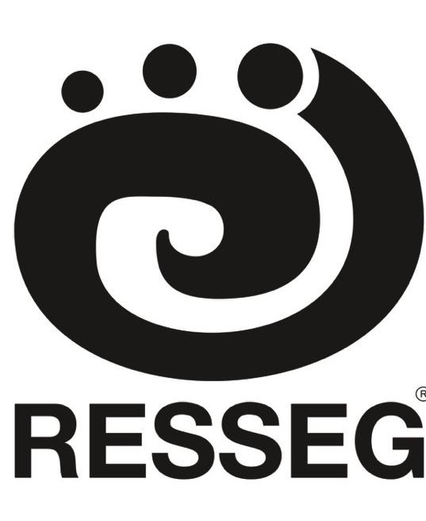
BARHAR https://www.barharrescue.com/collections/bags


France HABE Prize 2025

Form to be returned by email to: INTERNATIONAL UNION OF SPELEOLOGY
Secretariat of the France Habe Prize
Jean-Pierre Bartholeyns
jp.bartholeyns@gmail.com

NAME AND GIVEN NAME OF PERSON MAKING THE NOMINATION: ……………………………………………………………………………..............................................
ADDRESS: …………………………………..…………………………………………………..............
POSTAL CODE: …………..............TOWN: ………………………COUNTRY:..…………………...
TELEPHONE No: ………………………. CELL/MOBILE PHONE: ………………………………..
E-MAIL: ………………………………………….

NAME AND GIVEN NAME OF PERSON OR ORGANIZATION NOMINATED FOR THE FRANCE HABE PRIZE: ……………………………………………………………………………........................
ADDRESS: …………………………………..………………………………………………….............
POSTAL CODE: ………….............TOWN: …………………………. COUNTRY: ……………….
TELEPHONE No: ………………………. CELL/MOBILE PHONE: ………………………………..
E-MAIL: ………………………………………….

The nominator certifies by signature below to being aware of the rules of the France HABE Prize and to accepting all of its conditions.

Signature of the nominator: ………………………………………………………

Date: ……………………………………………….

